Student and Family Handbook Community Music School

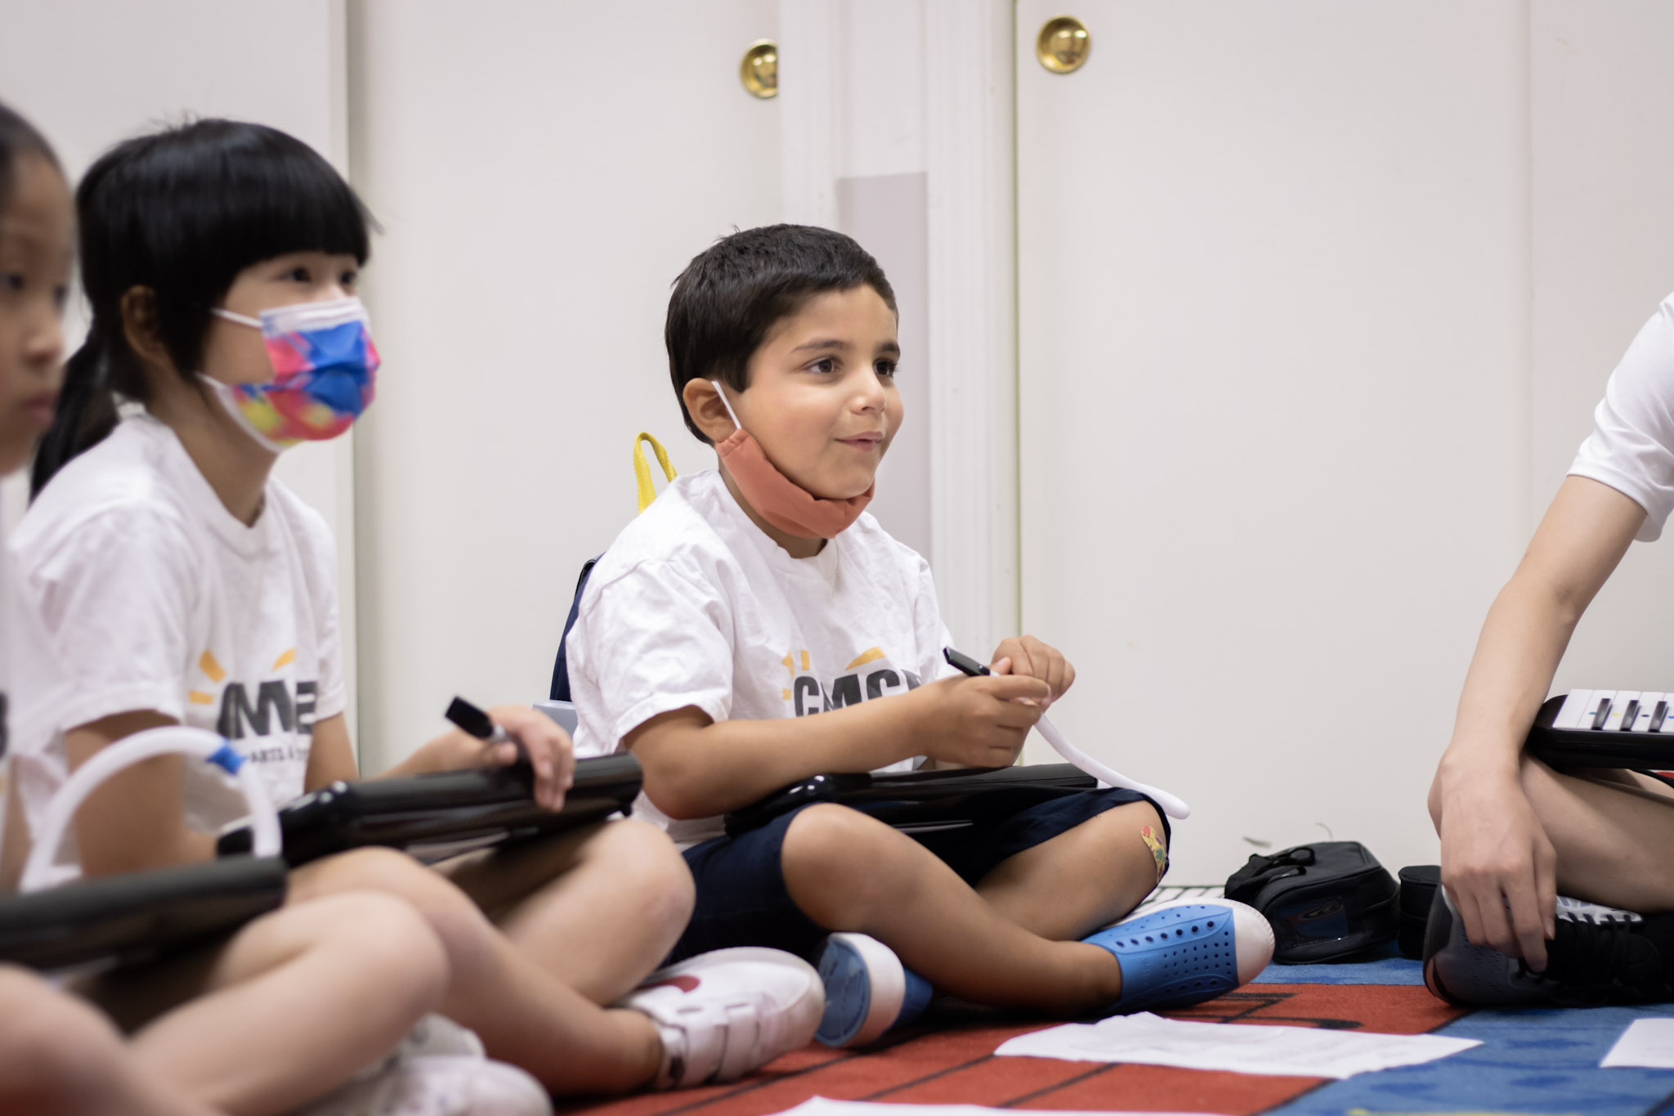

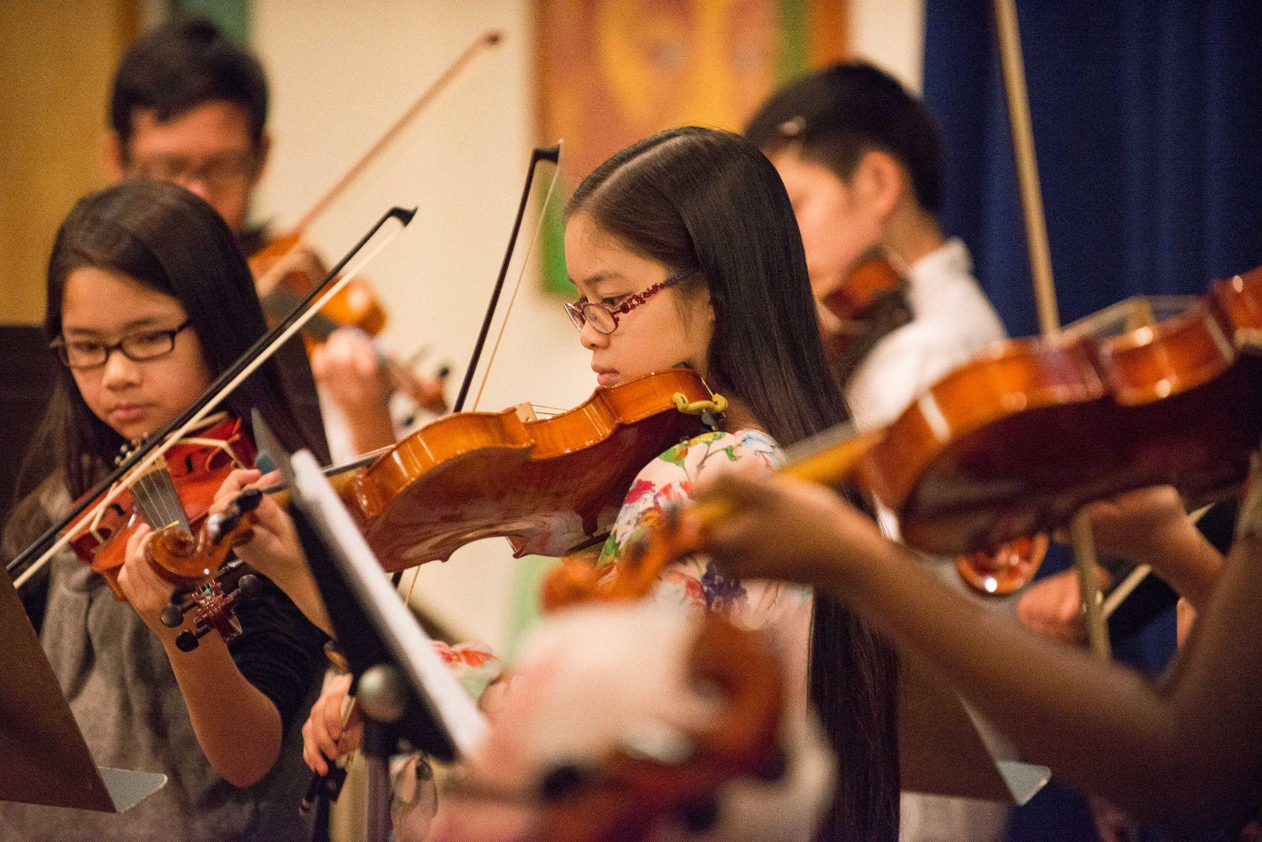
Mission
The Community Music Center of Boston (CMCB) is an arts education nonprofit founded in 1910, with a mission to transform lives by providing equitable access to excellent music education and arts experiences. Over 4,000 students participate in our programs every week. We are proud to act as the largest external provider of arts education to the Boston Public Schools, supporting rigorous, relevant, and culturally-inclusive musical instruction for one of the most diverse school districts in the nation.

Staff Contacts

While your Teacher should be your main point of communication for lesson content, student opportunities, recitals, and scheduling (with Registrars cc’d), CMCB Staff are also here to help! See the chart below to find out which Staff to communicate with with specific needs.

Role | Contact With Questions About:
Registrars | - Attendance Communications (student absences, schedule changes, etc.)  - Billing  - 国语翻译  - Registration Information
Communications Coordinator | - Comunicaciones en español  - Financial Aid  - Programming  - Receiving Keyboard Donations
Operations Coordinator | - Donating Instruments to CMCB  - Instrument Rentals
Senior Director of the Community Music School | - Curriculum  - Partnerships  - Student/Guardian Concerns
Chief Programming Officer | - Student Employment Questions

Student Policies

Attendance
Students are expected to attend all lessons and classes. If a student needs to miss a lesson or class, the student and/or Guardian must notify the Registrars and Teacher immediately. When possible, please communicate your absence to the Registrars and your Teacher as far in advance as possible.

Students and Guardians are financially responsible for all scheduled lessons/classes, regardless of absence and/or cancellation. School cancellations will be posted on our website, or you may call CMCB to check on the class status.

  - For Private Lessons:
    - One make-up lesson per semester is allowed to private students for lessons missed due to illness, family emergency, and school cancellations. Make-up lessons will be scheduled at the end of each semester during make-up week. Missed lessons are only made up in the semester they occur in.

  - For Group Classes
    - If a group class (Early Childhood, Elementary, Ensembles) is canceled due to weather, teacher absence, or emergency school closing, we will make an effort to reschedule the class during make-up week at the end of the semester. If we are unable to do so, the class will not be refunded or rescheduled. Make-ups and refunds are not provided for student absences from group classes.

Account
A Registration Fee is required prior to registering for any programming. Students and Guardians may choose from two payment options: payment in full upfront or monthly payment. Tuition payments must be made on time to avoid suspension of lessons and/or classes. Additionally, accounts must be up to date to register for programming in a new term.

Financial Assistance

Financial Aid is available to all families in all programs. Additionally, as part of the EBT Card to Culture Program, CMCB will award Financial Aid to any person who receives any EBT services. Financial Aid allocations depend on individual circumstance and may vary from year to year.

You may obtain an application for Financial Aid from the Registrars or on our website. Completed Financial Aid applications (including supplemental documents) are due within four weeks of starting programming to avoid suspension of lessons and/or classes. Financial Aid cannot be awarded retroactively for any prior school year. For any questions about Financial Aid, please contact the Communications Coordinator.

Refunds
Refunds will not be issued for Registration Fees or the first four private lessons or ensemble classes. If you wish to cancel after the first four lessons/classes, tuition will be prorated to the date of cancellation. Refunds may be provided if there is a Teacher Absence, or students may opt to reschedule their lesson at a mutually agreed upon date and time with the Teacher. CMCB does not provide refunds for student absences.

Withdrawal
If you wish to withdraw from programming, please notify the Registrars. Guardians and adult students are financially responsible for the first four lessons and any lessons/classes up until the date of office notification. There are no makeup lessons provided for students who withdraw.

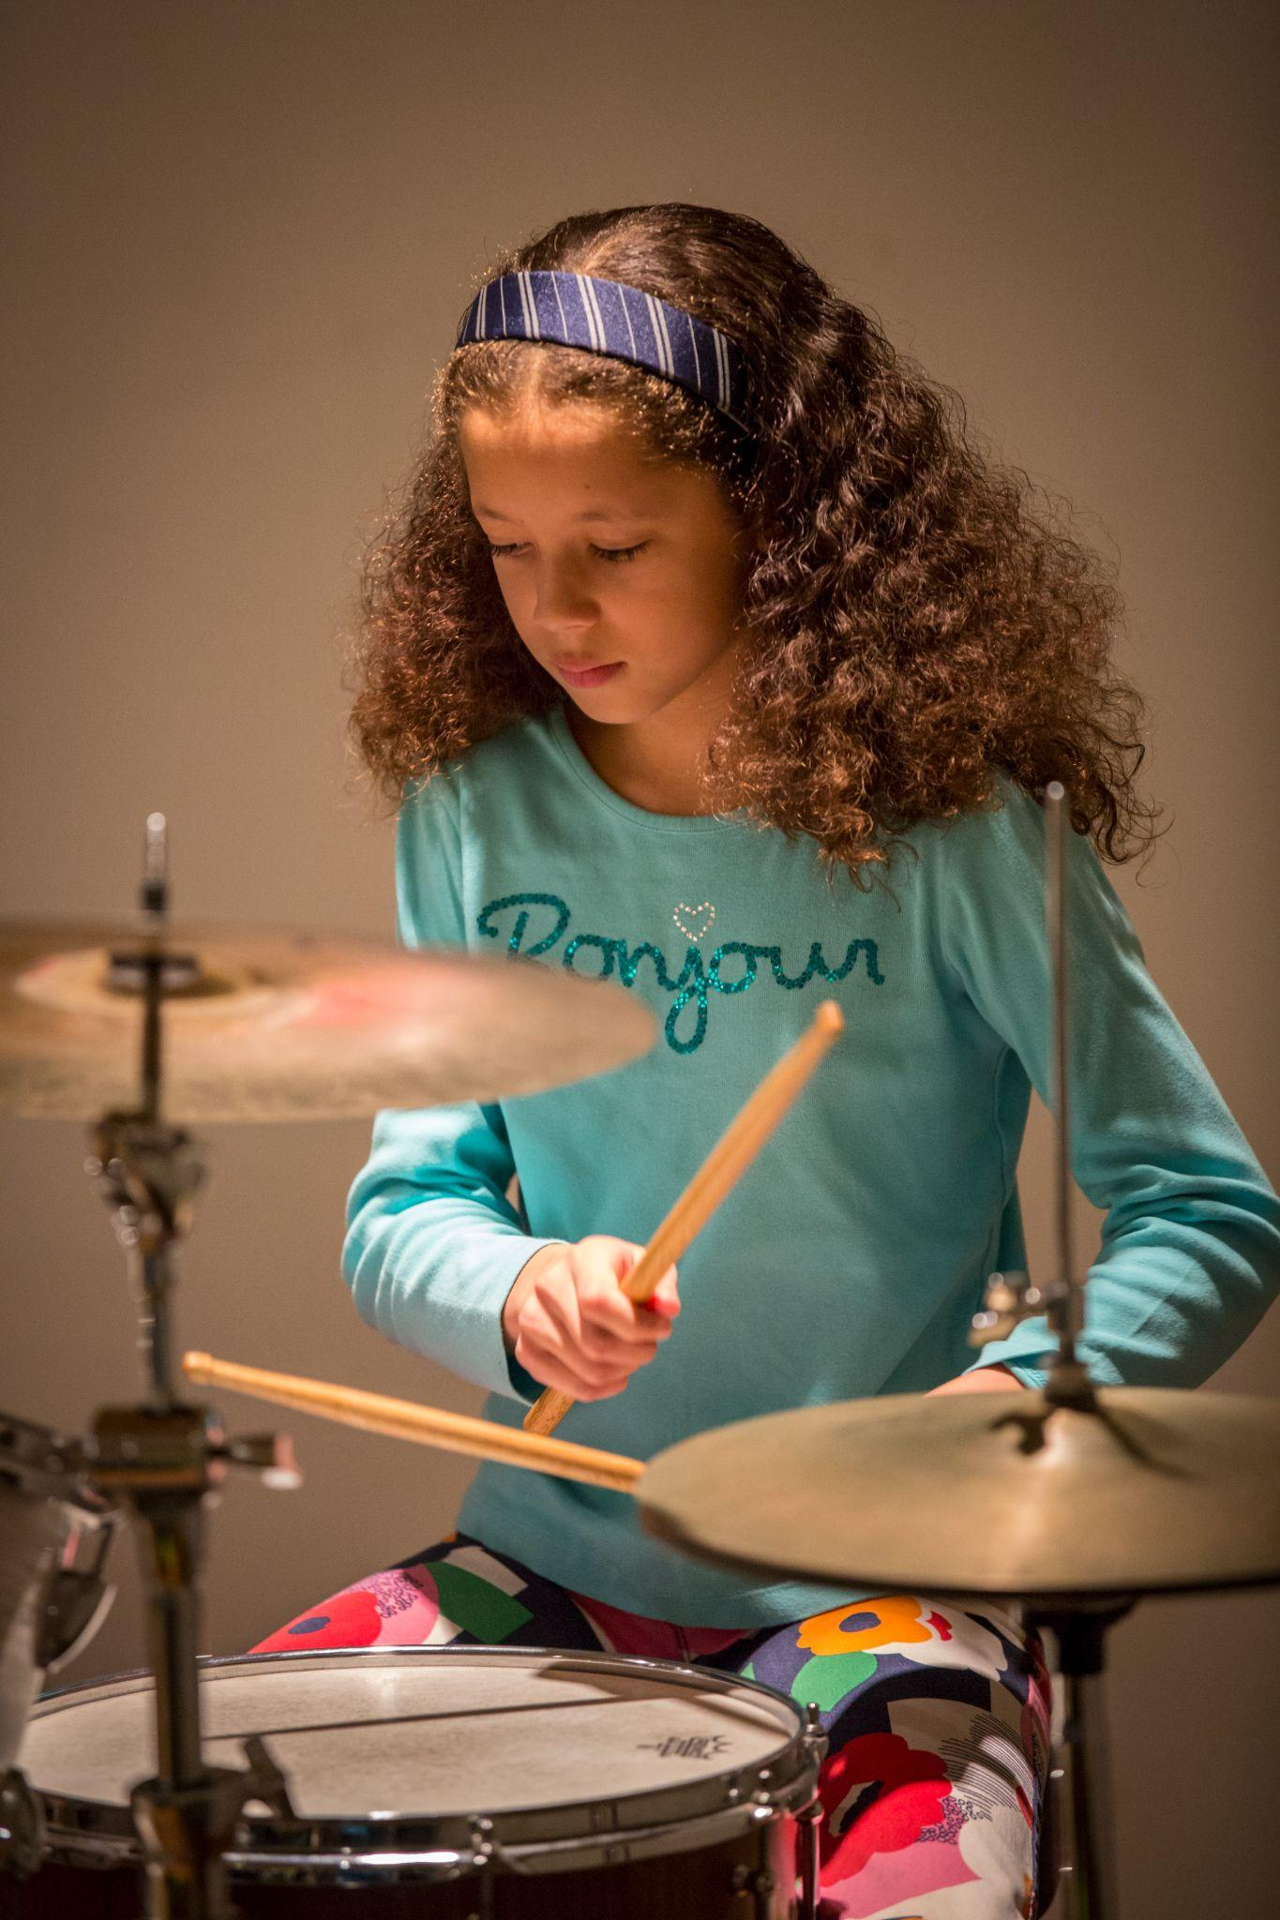
Class Eligibility
Students must be the minimum age required by the first class date of the session in order to enroll in Beginning Instrument classes or private lessons. Little Notes, Music & Movement, and Instrument Exploration students must be turning the minimum age within the first four classes of the session in order to enroll. Please refer to specific age requirements by instrument on our website or ASAP registration page.

Waiting Lists
When a class is filled, students will be placed on a Waiting List and will be notified if a spot opens up or another class is added.

Low Enrollment
If a class fails to meet the minimum enrollment by the fifth week of class, it may be canceled. If a class is canceled, families will be contacted by a CMCB staff member and given a choice of enrolling in another class or receiving a refund. Families will not receive a refund for Registration Fees.

Rental Instruments
Students may rent CMCB instruments for a fee of $65 per semester or $130 per year. Students should take good care of their instruments and let their teacher know as soon as possible if the instrument requires repairs or if they need a larger size. Students should return their instrument to their teachers after their last lesson or CMCB event of the term, unless they would like to rent over the summer ($30 fee). Students who wish to keep their instruments for future terms should notify their teacher(s) and the Registrars. Families will be billed accordingly.

Students must be enrolled in CMCB lessons/classes to rent CMCB instruments. Upon withdrawal or discontinuation of enrollment, any rented instrument(s) must be returned immediately. CMCB does not store instruments for students. If you are interested in renting an instrument at CMCB, please speak to your Teacher, who will guide you through the instrument rental process. Students/families must sign a CMCB rental contract before taking home a CMCB instrument.

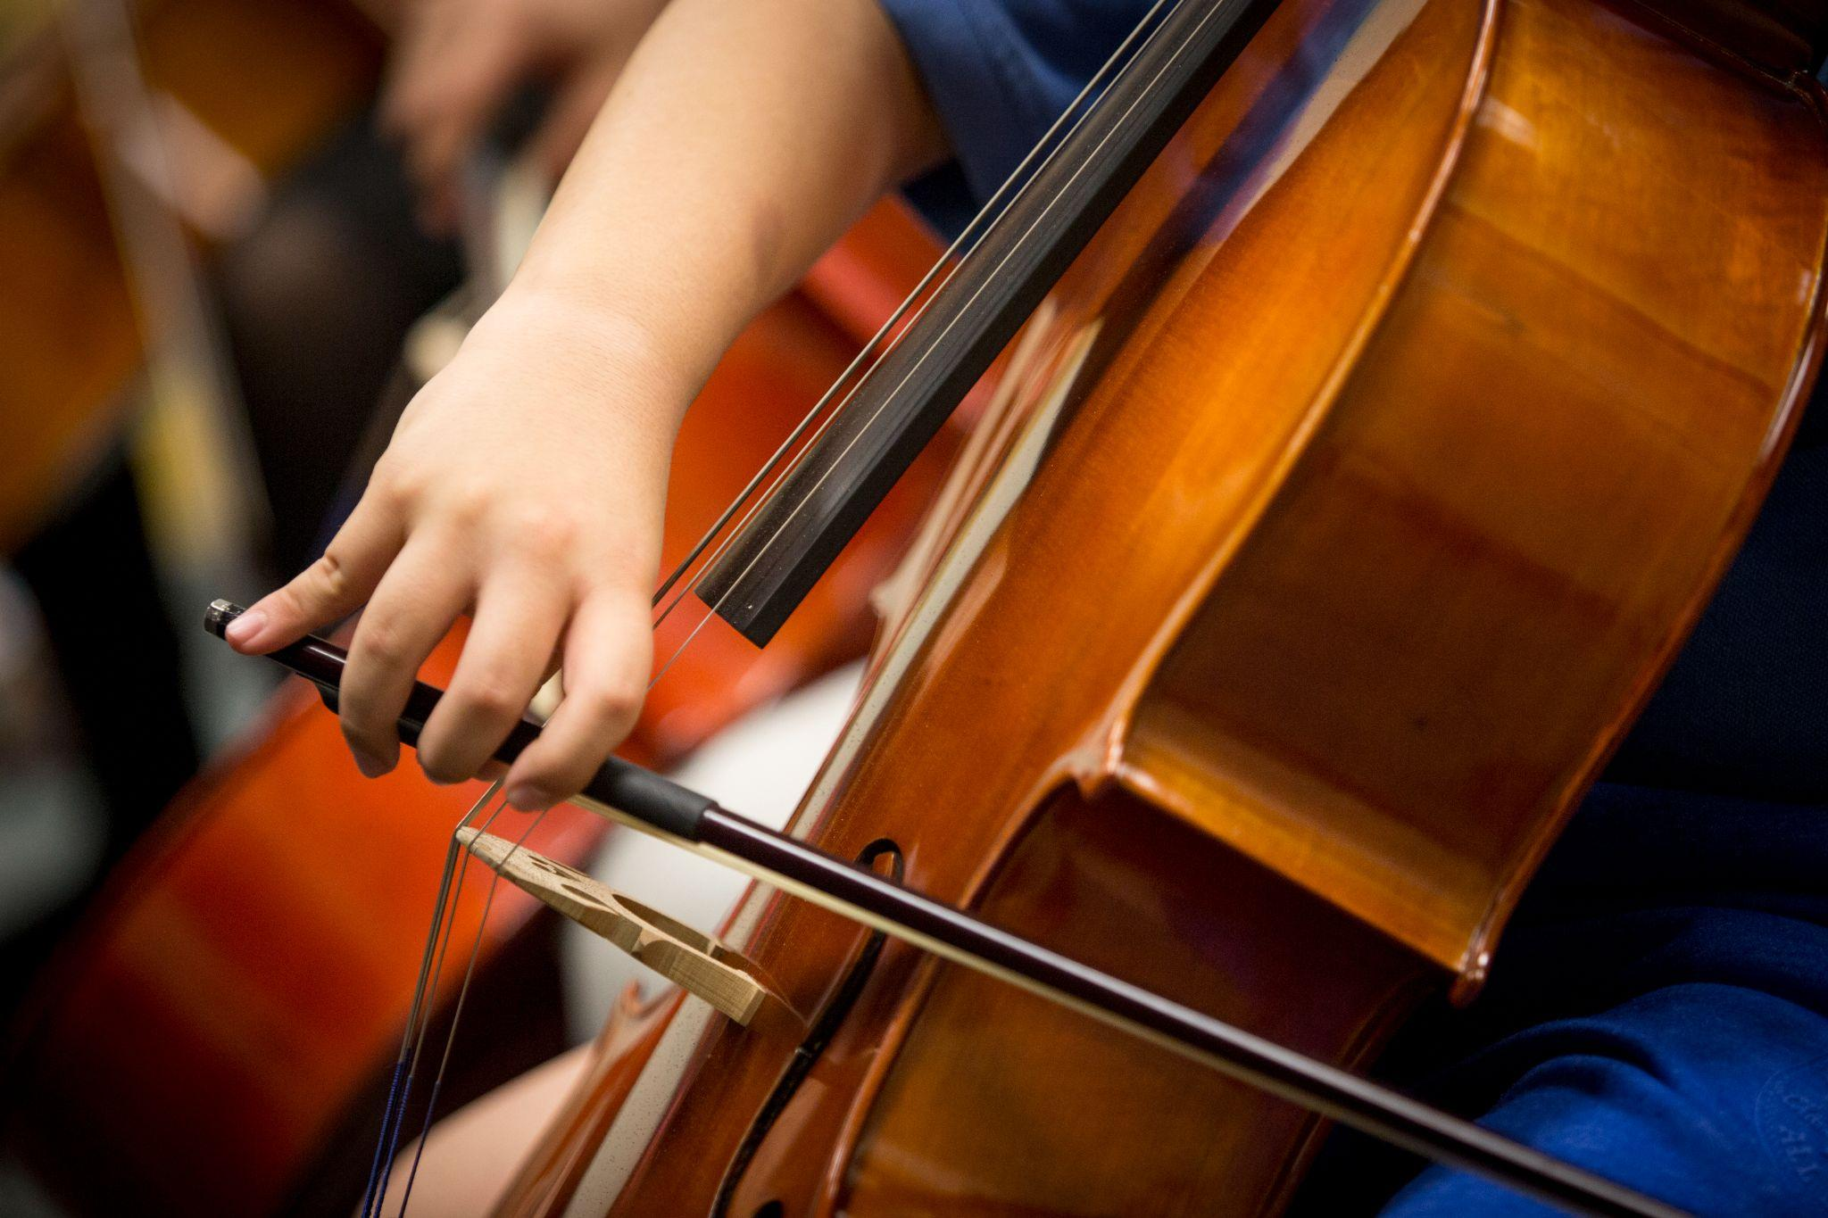
Student Conduct

On-site Conduct

Classroom Culture
Our space is shared by the CMCB community, and everyone’s care of the premises is important. Students should use respectful language and refrain from using profanity, inappropriate language/gestures, and other behavior that does not align with CMCB’s values. Students should be respectful of CMCB property such as shared instruments, sheet music, or toys in the lobby, and report any damage to the Registrars immediately. Smoking on CMCB premises is strictly prohibited. Please refrain from bringing food and beverages other than water into teaching spaces. If you eat or drink in the hallways or lobby, throw away any trash.

We encourage Guardians to be mindful that CMCB is a school space; please keep conversations in the hallways at a reasonable volume. Refrain from taking calls/meetings on speakerphone and use headphones when consuming media on devices.

Students should arrive on time for their lessons/classes with all necessary materials (instrument, sheet music, pencil, etc).

Guardian Supervision
Other than Caregiver Early Childhood classes, Guardian presence within lessons/classes is navigated on an individual basis between students and their Teacher. Please be mindful that some of our spaces are small, and Teachers may prefer that Guardians wait outside. For more information or accommodations please reach out to the Communications Coordinator.

Guardians are welcome to wait in Hallways and/or Lobby. Young children must be supervised by an adult at all times.

Concert Norms
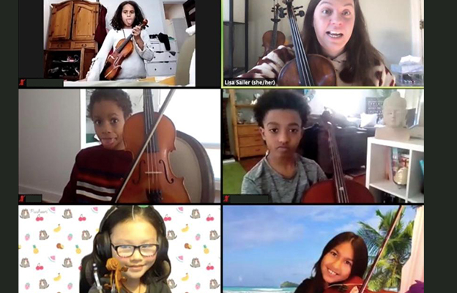
When possible, we encourage families and visitors to attend the full length of CMCB concerts. If you need to leave, please try and do so in between performances. Please refrain from talking, whispering, etc. during concerts. Cell phones and other electronic devices must be silent or turned off when attending performances.

Offsite Conduct
Regular online lessons must occur during CMCB’s regular business hours. Lessons with students who are under 18 years old should be conducted with an adult present. Although the adult does not have to be on the call the entire time, the adult must acknowledge the video call by appearing on screen or by providing additional written consent. Students should refrain from taking screenshots and/or screen capture video recordings of Faculty without express permission. Lessons and classes should occur in an open space or in a room with an open door.

CMCB is a school space, and students are expected to prepare for online lessons as they would for in-person lessons, with appropriate attire for school and a suitable space for learning. As in all CMCB activities, please be respectful and refrain from using inappropriate or discriminatory language or images.

Students and their Teachers must both be located in MA during all CMCB online lessons.

Closures
Announcements and school closures will be posted on our website and social media, and all students and Guardians will be notified via email. To minimize disruption in programming, CMCB may shift to online programming in the event of extended closure or inclement weather.

COVID-19 Policies
The Community Music Center of Boston remains committed to providing the most safe space possible for our faculty, students, staff, and community. For the latest version of our COVID-19 Health and Safety plan, visit https://cmcb.org/covid-health-safety-plan/.

Student Resources

Front Office Newsletter
The Front Office Newsletter contains helpful information about upcoming CMCB events, account and registration reminders, and community announcements. The Newsletter is distributed through email monthly to all registered families.

Library
CMCB has an extensive music library that students may borrow music from through their Teachers. Students are welcome to explore the library and speak to their Teachers to request any music they are interested in borrowing.

Practice Room Usage

Students may use CMCB studios at no cost for personal practice purposes during normal operating hours when they are available. Please check with the Registrars for room availability before using any studios. Studio availability is subject to change and not guaranteed.

Student Opportunities
In addition to offering private lessons, classes, and ensembles, CMCB offers the following musical and administrative opportunities to interested students:
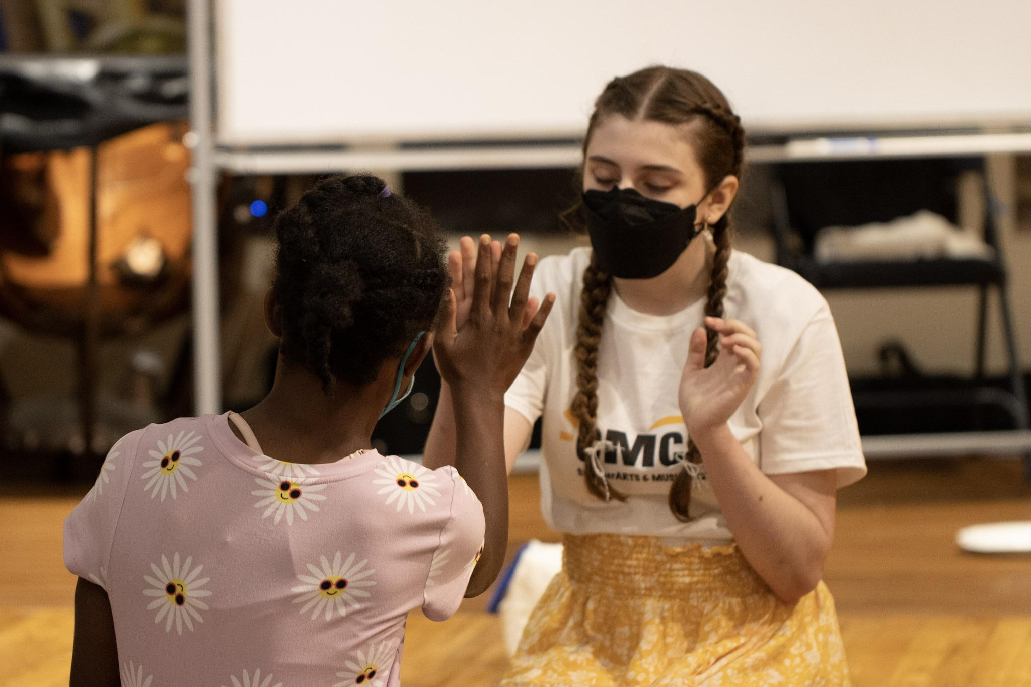
- Intensive Study Program (ISP): ISP is CMCB’s in-house program for students grades 7-12 who are interested in increased engagement in the CMCB community. The ISP curriculum includes private lessons, ensembles, music theory and composition, and seminar classes. Students interested in the ISP program should contact their Teacher to indicate their interest.
- Chamber Music: In addition to existing ensembles, students may register for an ongoing chamber group with other CMCB students, coached by a Faculty member. Please contact the Communications Coordinator if you are interested in chamber music at CMCB.
- Youth Employment/Volunteer Opportunities: CMCB offers youth employment and volunteer opportunities to high school and college students ages 15+ interested in arts administration. For more information, email the Chief Programming Officer.

Student & Family Resource Page

The Student & Family Resource Page on the CMCB website contains information such as the annual calendar, updated student policies, additional student opportunities, and more. To access the page, visit https://cmcb.org/student-resources/ and type in the password CMCB1910!

Annual Calendar
CMCB offers many community music events for students and families throughout the year. These events enrich students’ musical experience beyond weekly lessons/classes, and students are highly encouraged to attend. To find specific dates for the following events, please consult the CMCB Calendar and communications from your Teacher.

Student and Family Orientation (September)
All adult students and/or household heads are encouraged to attend our Fall Orientation to learn CMCB policies, meet CMCB Staff, and see the space. For those who cannot attend or who enroll later in the year, materials from the Orientation will be available online.

Winter Recitals/ECH Culminating Events (December)
All Early Childhood Classes, as well as many private studios, host Winter Recitals where students may perform for their families and friends.

Performathon/Young Composers Festival (February)
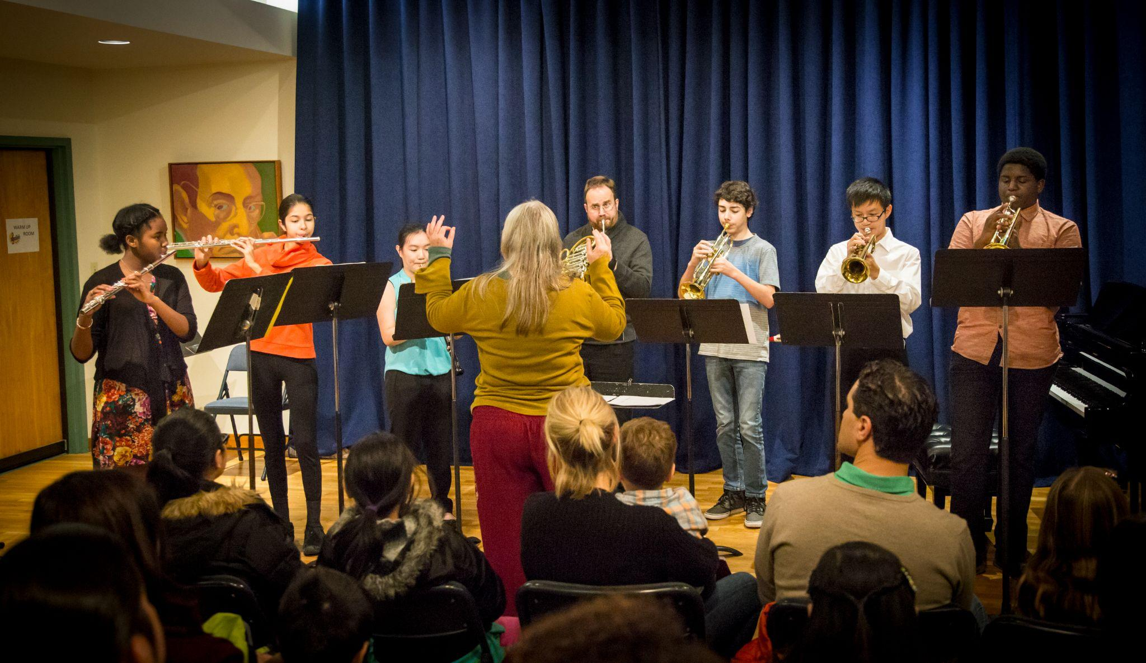
The Performathon is a multi-day performance marathon and fundraiser of mini-recitals ranging from
Mozart to Marley, rock to Rachmaninoff, Schumann to show tunes. Performathon is also an annual fundraiser where 100% of the proceeds benefit CMCB’s Financial Aid program. Performances include all instruments and ensembles. The Performathon typically features more than 400 student performers— aged 5 to 85. Even entire
families have performed together!

In recent years, Performathon has been combined with the Young Composers Festival (YCF). YCF is a 3-day festival of new music by young composers, and fun, challenging workshops for the whole family. YCF presents various workshops, panel discussions and concerts by and for students of all ages. Young musicians work alongside professional composers and performers to create and perform contemporary music. Opportunities include collaborative workshops, reading sessions, visual arts, and improvisation. There is no cost to participate in the festival and all students are encouraged to attend. YCF is open to the public.

Student Evaluations (March)
During Student Evaluations, CMCB private lesson students meet with one or more Faculty members in their department and receive feedback in lieu of their lesson for a week. Student Evaluations help students assess their own growth and reflect on their musical goals. Students may opt out of Evaluations, and/or choose to schedule a Guardian-Teacher conference during that time instead.

Lapin Competition (April)
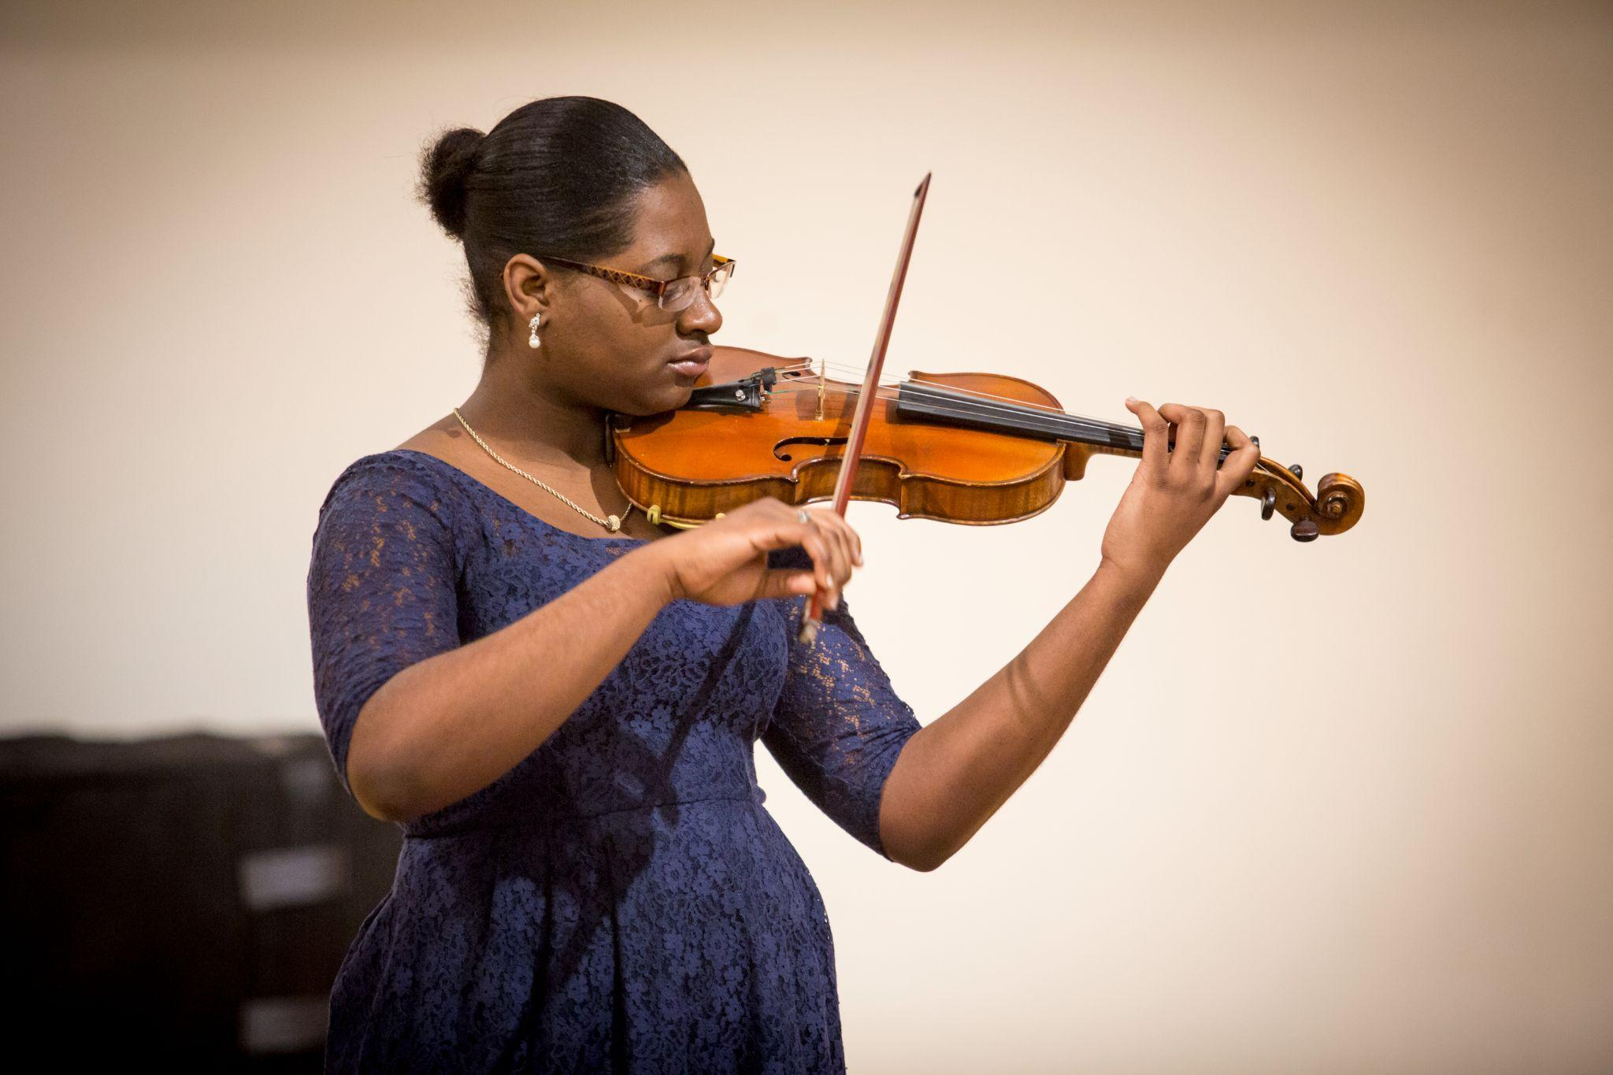
Named in recognition of former CMCB Executive Director David Lapin, this annual performance competition is open to all CMCB students currently registered in programming. The Competition features a Preliminary and Final rounds, evaluated by guest judges. Participants compete for cash prizes in either a Junior or Senior division based on age:
- Junior Division: Open to students in 9th Grade and younger (not recommended for beginners). The work(s) should be Intermediate in level, and the total performance length should be 5-12 minutes.
- Senior Division: Open to students in 12th Grade and younger. The total performance length should be 5-12 minutes.
Students interested in entering the Lapin competition should let their teacher know early in the Spring. Their Teacher will then help them choose appropriate repertoire, coordinate rehearsals with an accompanist (if applicable), and help them prepare for the Competition.

Spring Recitals/ECH Culminating Events (May/June)
Most private studios, as well as all Early Childhood Classes, will host Spring Recitals in May or June. Your Teacher will communicate with you throughout the Spring to schedule this recital.

Fête De La Musique (June)
Since 2012, CMCB has hosted an annual music festival called Fête De La Musique with performance opportunities, giveaways, food, and games. Programming occurs outdoors in the South End, throughout various public parks. Fête brings together professional musicians and bands with CMCB students to perform for attendees from across the CMCB Community, the South End, and the city of Boston. Fête is a sunny and joyous way to celebrate the end of the school year together!

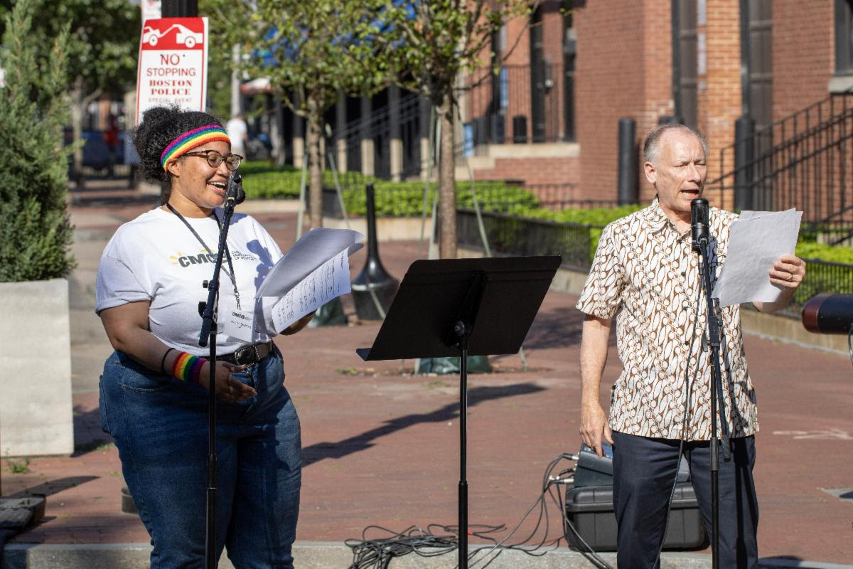

CMCB Terminology
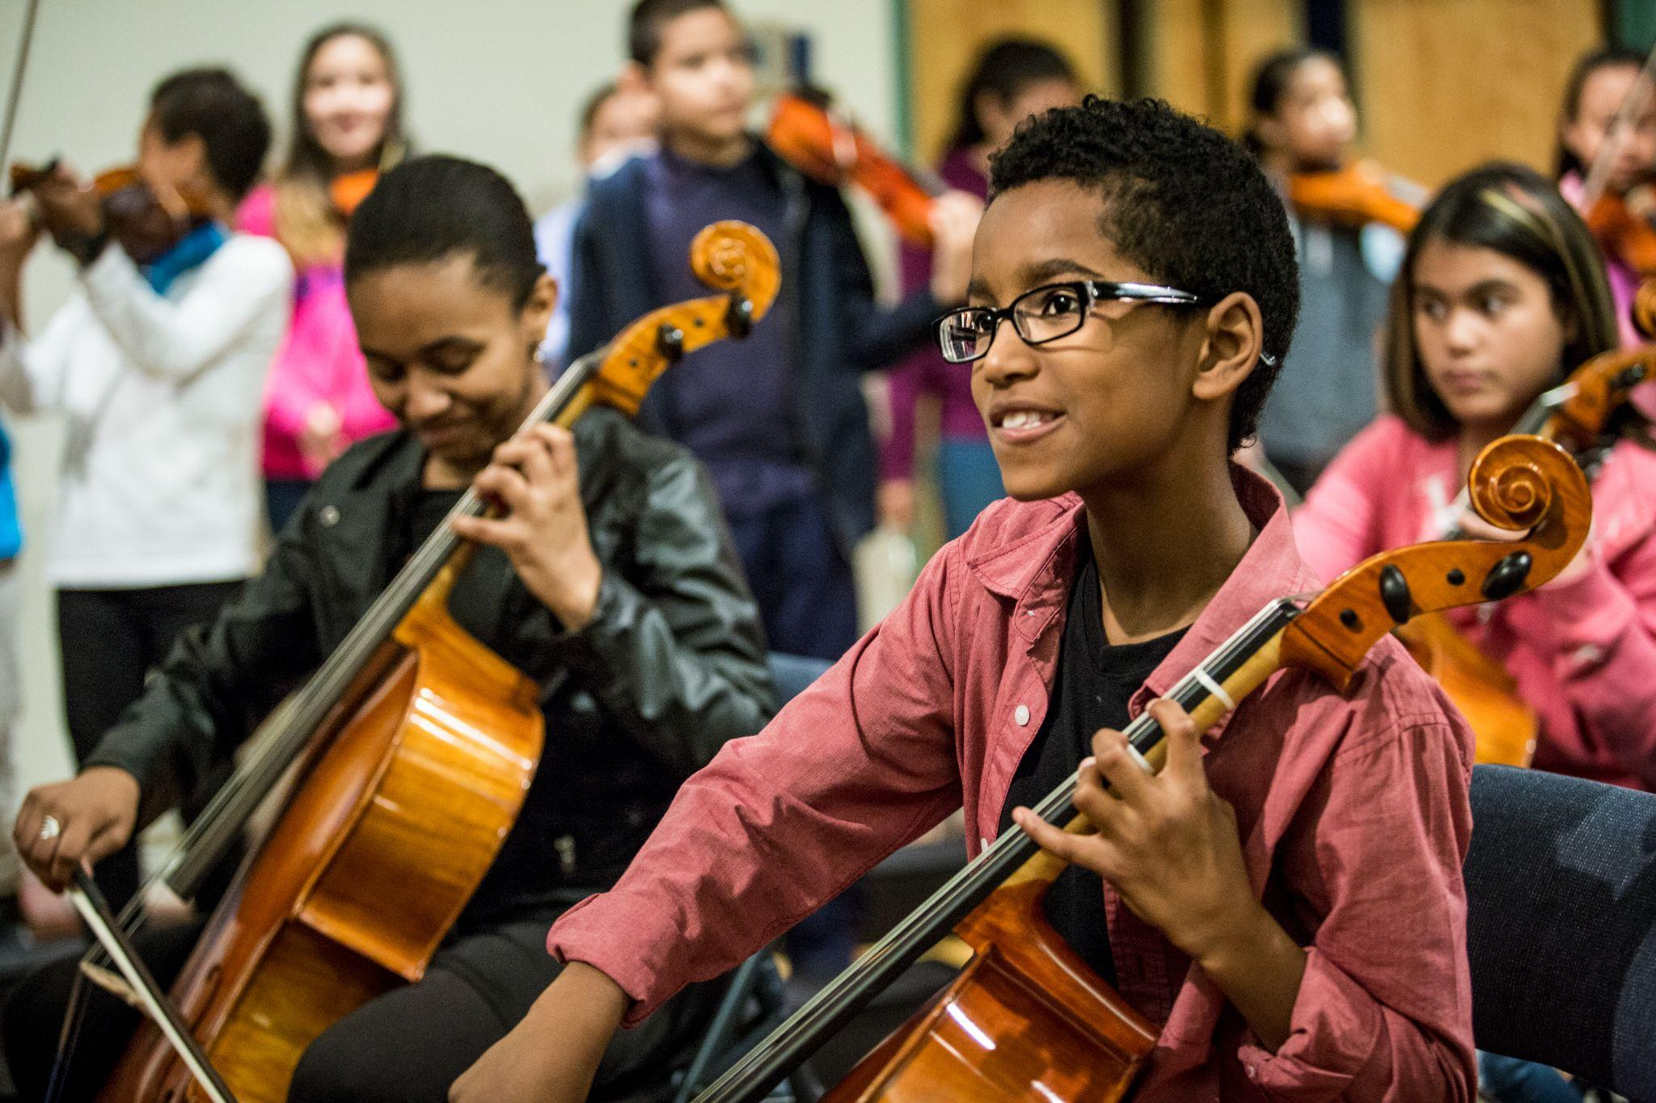
- Evaluations: During Student Evaluations, CMCB private lesson students meet with one or more Faculty members in their department and receive feedback in lieu of their lesson for a week. Student Evaluations help students assess their own growth and reflect on their musical goals.

- Ensembles: An ensemble is made up of three or more students who play music together with a primary goal of making music as a team. CMCB Ensembles include orchestras, smaller chamber groups, and even an adult choir!

- Group Classes: A group class is made up of three or more students who play music together with a primary goal of each student developing a deeper relationship with their music-making. Most CMCB group classes are for ages 4-12.

- Recitals: A recital is an opportunity for students to showcase their musical work to their peers, friends, and families. Recitals usually last no longer than one hour and take place in Allen Hall.

- Seminars: Seminars are an opportunity for students to study together in a class setting. Led by a CMCB Teacher, students will learn from each other through performances, peer review, and class demonstrations. When enrolled in a seminar, students attend weekly class meetings that supplement but do not replace their private instruction assignments.

- Workshops: A workshop is an opportunity for students to practice some of the skills they have learned while gaining feedback from peers and faculty. A workshop is a great way to get performance exposure in an informal environment. Students not only learn from their own performance, but learn from their peers’ performances and are encouraged to give feedback based on their observations. Workshops are scheduled throughout the year for students at different levels, and do not require registration.

