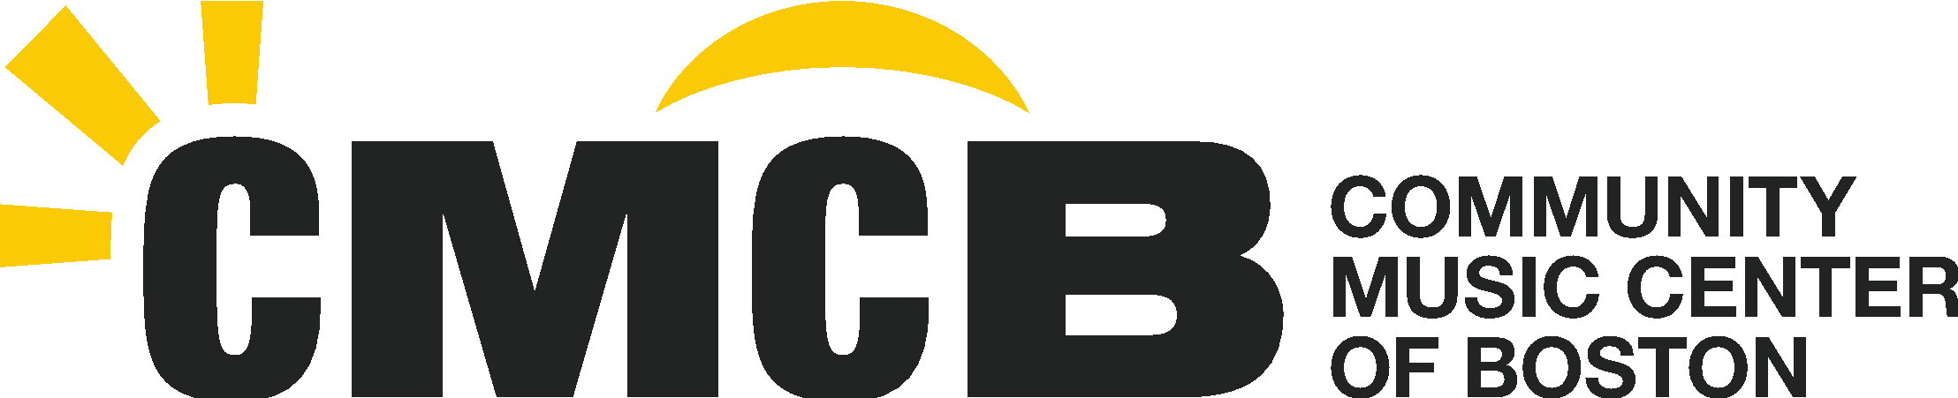
2021 Welcome Letter from Executive Director Lecolion Washington
CMCB.ORG
T 617.482.7494
F 617.482.6267
34 Warren Avenue Boston, MA 02116

CMCB Community,

What a year it’s been!

At this time last year, we were all extremely unsure about what the next year would hold. We had no clarity on where the coronavirus was taking us. We didn’t know when or if there would be a vaccine. We were aware of the emotional and mental health challenges that many would face. We were also hyper focused on city-wide “Phases,” “racial awakenings,” and national elections. Needless to say, there was a lot to process.

Here at CMCB, we didn’t know if any of our community partners would be with us, and as the largest outside providers of arts education in BPS, we were thinking about the students whose lives we would not be able to support with our work. We knew that we wanted to open our doors in the South End and continue to engage directly with our community, but we didn’t know how many of you would respond. Everything was up in the air. But like CMCB always does, we rallied. We supported over 2,500 classes taught in our Community Engagement Programs (CEP), and over 10,000 lessons in our Community Music School (CMS) last year.

Today, we’re still living with some uncertainty, although it is different than before. Although there are still concerns about the delta variant, many of us are feeling a bit more confident about the future since the vaccine became available. The isolation that we have all experienced has reminded us just how much we need each other, not just for the world to be a better place, but also for our individual lives to be purposeful and fulfilling.

Many of us are starting to see the healing light at the end of the tunnel, but none of us knows exactly where the tunnel is taking us. It is in this type of spirit of healing that we start our new year.

As CMCB continues to work to become a more inclusive organization, we recognize that healing means different things for different people. For those of you who are ready to join us in person, please know that, as safely as we can, we will be inviting you back to in-person music programs and events. This includes more in-person educational offerings on-site and with partners, as well as hybrid in-person and online CMCB events such as our Parent Orientation on September 11, the John Kleshinski Luncheon October 24, Performathon, Young Composers Festival in January, Fête de la Musique (our tenth annual!) in June, as well as our concert and speaker series, the John Kleshinski Concert Series and Community Conversations. Please visit our website at www.cmcb.org and sign up for our emails for more information about these events.

If additional restrictions come from the city, then of course, we would revisit our plans, but for now, we want to once again make music together and in person wherever possible. For those who have your individual reasons for wanting or needing to continue your time away from in-person events, please know that we will continue working to have virtual and hybrid events so that you can stay engaged with us.

Looking forward, we are excited to share that CMCB has completed the creation of what we believe will be a revolutionary strategic plan for community music schools! Our new plan is centered around the vision of supporting children, young people, and adults to engage in equitable, culturally inclusive, and learner-centered music education programs. In order to be more collaborative and participatory with all of you, we will be sharing key components of this plan throughout the year, so stay tuned!

As we look to this year, I’d like to share a story from a wonderful conversation that I had with a CMCB parent who is also an educator. She told me that, because she needed to school her son from home due to the pandemic, she became more than a mother to her son. She also became his teacher - yuck! She said that, as someone with very little musical knowledge, her relationship with her son was saved through his weekly piano lessons. She laughed as she reflected on the fact that, although she was the expert in education, her young son was the house expert on the piano, confidently showing her how to find middle C. At home, the music was his, and his alone, and this balancing of the power dynamics between them were critical for their relationship.

This story resonated with me on so many levels. Not only was this an example of a young person developing confidence and agency through music, but it was also a student who was engaging with music as an opportunity to relax rather than as a chore. It reminds me of all the amazing impact that music can have beyond just the craft of manipulating an instrument. Its impact can support the building and strengthening of communities, it can be a beacon of light as we work toward being more culturally inclusive, it can remind us that it’s ok to have fun and escape the everyday through music, and it can play a role in helping us heal from the effects of a global pandemic.

And it is for all of these reasons that CMCB will be here for you -- our community -- as we have been for over 110 years.

We look forward to engaging with all of you this year!

Sincerely,

Lecolion Washington
Executive Director

